**Activity Diagram**

An activity diagram illustrates the dynamic nature of a system by modeling the flow of control from activity to activity. An activity represents an operation on some class in the system that results in a change in the state of the system. Typically, activity diagrams are used to model workflow or business processes and internal operation. Because an activity diagram is a special kind of state chart diagram, it uses some of the same modeling conventions.

**Basic Activity Diagram Symbols and Notations**

**Action states**

Action states represent the non interruptible actions of objects. You can draw an action state in Smart Draw using a rectangle with rounded corners.

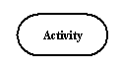

**Action Flow**

Action flow arrows illustrate the relationships among action states.

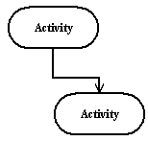

**Object Flow**

Object flow refers to the creation and modification of objects by activities. An object flow arrow from an action to an object means that the action creates or influences the object. An object flow arrow from an object to an action indicates that the action state uses the object.

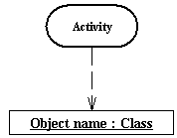

**Initial State**

A filled circle followed by an arrow represents the initial action state.

Initial State

**Final State**

An arrow pointing to a filled circle nested inside another circle represents the final action state.

Final State

**Branching**

A diamond represents a decision with alternate paths. The outgoing alternates should be labeled with a condition or guard expression. You can also label one of the paths "else."

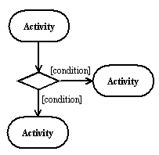

**Synchronization**

A synchronization bar helps illustrate parallel transitions. Synchronization is also called forking and joining.

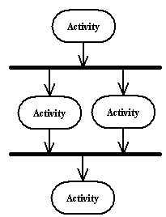

**Swim lanes**

Swim lanes group related activities into one column.

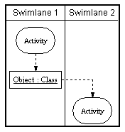

Activity Diagram



Fig: Admin Activity Diagram



Fig: User Activity diagram